15.02.2022г. группа 1ТМ 3 пара
Дисциплина ОДБ.03 Иностранный язык
Преподаватель Романюта Маргарита Вадимовна
Занятие № 5
Модуль 1 «RELATIONSHIPS»
Тема 1.5. История Англии
Цели:
• Образовательная – расширение эрудиции студентов, их общего и лингвистического кругозора на основе практического овладения английским языком;
• Практическая–
1. Развитие навыков чтения, устной речи.
2. Совершенствование коммуникативно-познавательной компетенции студентов по теме «История Англии».
• Развивающая – развитие языковых, интеллектуальных и познавательных способностей студентов.
• Воспитательная – воспитание внимательного отношения к своему здоровью, привитие навыков здорового образа жизни, формирование общей культуры студентов.
Литература
1. Афанасьева О.В., Дули Дж., Михеева И.В., Оби Б., Эванс В. УМК «Английский в фокусе» для 10 класса, М.: Просвещение; UK.: Express Publishing: 2018;
2. Агабекян И. П., Коваленко П. И. Английский для технических вузов. Феникс, Ростов-на/Д, 2019.
Дополнительные источники:
- Ионина И., Саакян А. Английская грамматика. Теория и практика. – М.: Академия, 2018.
- Бережная О. О. Сборник новых тем современного английского языка. Донецк, 2019.
Справочники:
- Мюллер В. К. Англо-русский и русско-английский словарь. – М.: ЭКСМО, 2017.
Интернет-ресурсы:
- Портал по изучению английского языка.
Форма доступа: http//www.englishlanguage.ru.
- Сайты для изучения английского языка.
Форма доступа: http://www. study.ru – English Info
http://www.native-english.ru
http://www.study.ru
http://www.homeenglish.ru

1.Работа с лексикой
1.1.Прочитайте слова в словаре WL 3-4.
1.2.Запишите в тетрадь слова с транскрипцией.
2. The picture, taken by John Thomas in 1885, shows a Victorian family, a family that lived during the reign of Queen Victoria in 1837-1901.
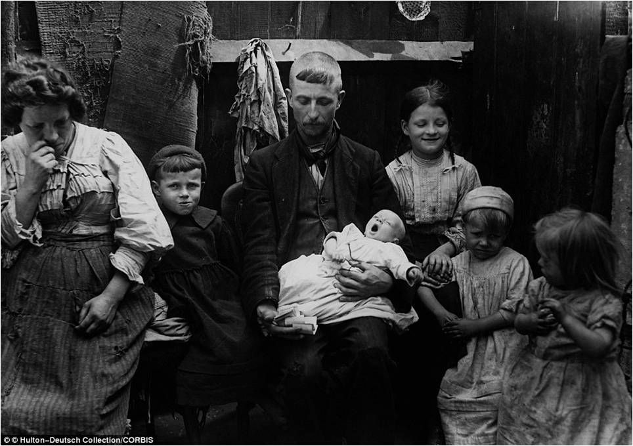
2.1.Write your answers
1) Is it a working class family? Why?
2) Where are they?
3) What are they dressed in: everyday clothes? best clothes? Why?
4) Who seems to be the head of the head of the household? Why?
3.Работа с текстом.
3.1. Read the text. Use the words in brackets (1-10) in the correct form to complete the gaps.

Upper & Middle Class Families
Families were very important to Victorians. They were usually large, with an average family 1).....(have) at least five or six children.
The father, who perhaps worked in banking or insurance, was the head of the household The children would speak 2).....(polite) to him, and call him "Sir". The mother was responsible for 3)...... (run) the household and would usually spend her time planning dinner parties or visiting her dressmaker or friends. Children saw very little of 4).... (they) parents and spent most of the day in the nursery with a nanny as Victorians firmly believed that a child should be 'seen and not 5)........... (hear)'!
Upper and middle class families lived in large, 6).......... (comfort) houses and had servants such as a cook and kitchen maids to prepare the family meals, a butler to answer the door and wait on the family, and housemaids to carry out household chores such as washing clothes, cooking and cleaning.
For entertainment, families 7)......... (visit) new parks and museums, such as the Victoria and Albert Museum.
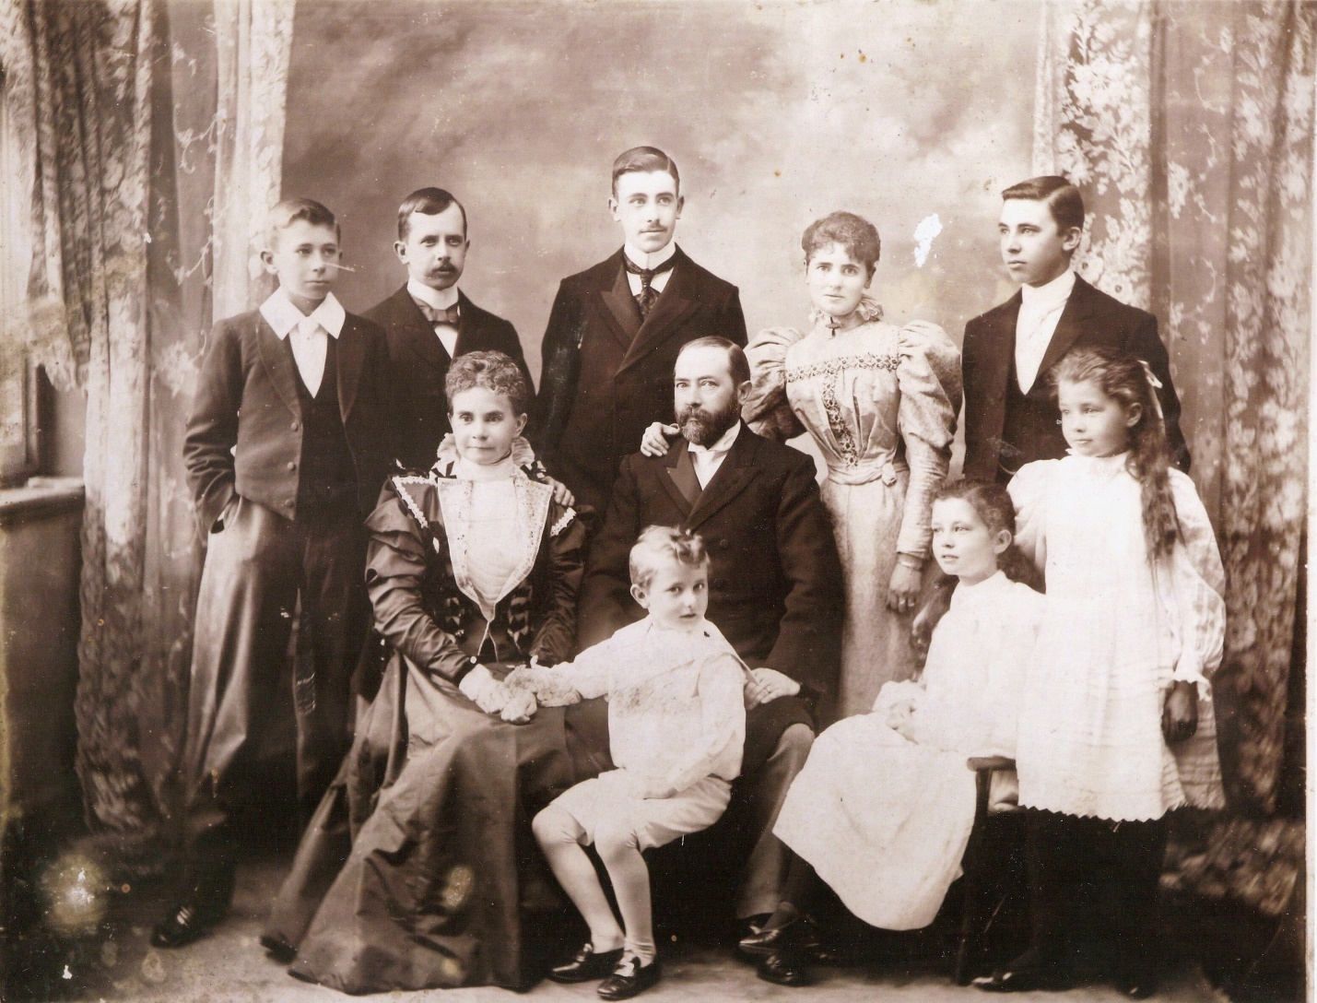

WORKING CLASS FAMILIES
Most of these families lived in small houses. Often several families lived in a single room. Houses had no running water and it was not 8)........... (common) for a whole street to share two 9)..........(out) toilets and a water pump.
It was very common for poor families to have as many as nine or ten children, many of whom didn't go to school. Instead, they looked after their 10.........(young) brothers and sisters or even worked. In Victorian Britain, children as young as three or four years of age, worked up to 16 hours a day in coal mines, in cotton mills and as chimney sweeps. The father of the house often worked in a factory while the mother was responsible for all the household chores.
For entertainment, working class families went to parks, cheap music halls or to gardens which had fairgrounds, sports matches and fireworks displays.
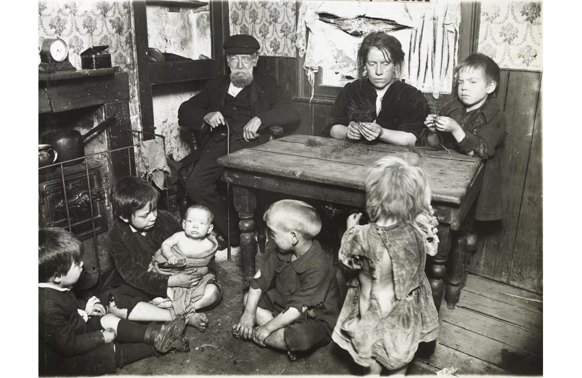
3.2. Explain the words in bold. Write your answers.
Домашнее задание:
1.Письменно выполнить упражнения 2.1, 3.2 данного занятия.
2.Write about the two types of Victorian families.
Срок выполнения задания до 21.02.2022.
Все работы выполнять в рабочих тетрадях, фотографировать и отправлять на адрес преподавателя Романюты М.В. rita.romanyuta@mail.ru

